Lullaby Presentation

Some ideas and suggestions on how to tackle the upcoming presentation.

*I would like to stress that I don’t personally think we should fret too much about this. It does not factor into our grade, nor change the fact that we’ve made a kickass game. If anything the Winter Games expo feels more important. We could consider this a bit of a testrun for then.*

# The brief:

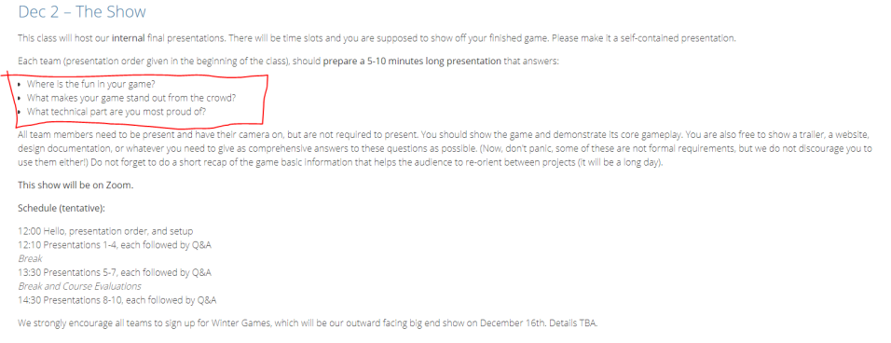

## Formal stuff:

* 5-10 minutes in length.
* A self-contained presentation.
  + My understanding: presentation should not depend too much on what was previously shown, what isn’t shown during the presentation, references to other games that are not readily understood by the audience, etc.
* A short recap of the game.
  + Basic information: engine used, controller requirement, sound requirement, etc.
* Everyone needs to be present, with webcams on. Not everyone needs to present.
  + My opinion: we should limit presenters to just one or two members. People interrupting each other can seem very unorganized or even rude.
    - Maybe one designer, one tech?
    - Of course, other members should be ready to answer more specific questions (tech, QA procedure, sound production, etc).

## Content of presentation:

* “You should show the game and demonstrate its core gameplay.”
  + We will not be able to show the game in its entirety. We could use level select to show different parts? Or one uninterrupted section?
* An answer to these questions three:
  + “Where is the fun in your game?”
  + “What makes your game stand out from the crowd?”
  + “What technical part are you most proud of?”
* “You are also free to show a trailer, a website, design documentation, or whatever you need to give as comprehensive answers to these questions as possible.”
  + We have some really nice concept art. A comparison between the initial pitch by Martin and the final game would be a neat way of showing the strength of the concept/vision.
  + We could use a video to ensure a problem-free experience but at the cost of being able to show the experimental and expressive qualities of the song wheel!

### The answers:

##### *“Where is the fun in your game?”*

* Cute animations and sound.
* A wide array of puzzles.
* Melodies, chord-making, and the expressive qualities of the song wheel.
* Some truly juicy moments!

##### *“What makes your game stand out from the crowd?”*

* The emphasis on sound and singing as a way to interact with the world.
* A curious blend of cuteness, dark atmosphere, and occasionally difficult puzzles.

##### *“What technical part are you most proud of?”*

* Juicy moments. The song wheel.
* I’m sure there’s some impressive technical feats that I am completely ignorant of.

## Reflections:

* The ergonomics is a big talking point. I think it’s fine to be perfectly honest about how we believe that the system generally works but could be improved on in many different ways.
  + This is a point where comparisons are likely to be made to other games. Why did we settle on this version of the wheel? Did we consider alternatives?
  + I can feel Pichlmair’s presence like:
    - 
* Target audience: We haven’t given this too much thought but it’s nice to have a “canned” answer, if it gets brought up.
* Colorblindness and the role of color in this game.
  + “Couldn’t you just play this game muted?”
    - Motherfucker, we made our game accessible for deaf people and you didn’t even notice.
* Influences: we’ve spent comparatively little time playing or talking about other games. If they bring up Wandersong, I swear to Buddha…

Presentation:

* 2D puzzle platformer
* Focus on interacting with world with song (your notewheel) which allows you to play melodies but also interact with the world and solve the puzzles
* Emphasis on sound and atmosphere: animation, in how you are producing music from just solving the puzzles and the Triangle is singing
* It features four distinct branching tied together with a beginning, middle and end where the middle contains two branches. It takes around 30 minutes.
* Properly introduce wheel mechanic with functionality

What makes the game fun:

* The melodic interaction with the world around you. You are solving
* Concept art, strong theme throughout process as well as emphasis on character
* 2D puzzle platformer, set in a dungeon.
* Show character, interaction system, the fun in the game and atmosphere
  + Cute animations and sound.
  + A wide array of puzzles.
  + Melodies, chord-making, and the expressive qualities of the song wheel.
  + Some truly juicy moments!t Show bell
* Level layout:
  + You navigate and solve puzzles to proceed. It is structured around a beginning, a middle that branches out in two directions for you to follow and follow and end
* What sets us apart is the notewheel, show interaction with puzzles and the truly juicy moments
  + The ease of use and how it is made instrumental for using in part with platforming and level design / show drawbridge
    - You can also just pull up this game and just play music
  + The game is tailored for people other than musicians to be able to play music. Scale is never dissonant, puzzles are not tied to musical knowledge
    - color blindness is accounted for which allows colorblind as well as people with no musical background to play
  + Art: tiles, sprites by hand. Sounds, edited and put together in FMOD. Lighting works with the tiles and sprites and contrasts with grey. Lots of thought put into these expressive elements of our game and having them work with the programming and gameplay.
* End: show last level. Short recap of what this game is. Music play, interaction, atmosphere.